The trade-offs inherent in the Islands design mean that some people will be turned off of wanting to use it. The Islands team believe that this is an acceptable trade-off. (Some “missing” features that don’t constitute security risks are simply missing because they don’t fit with available time and current priorities. Those will get addressed or not as time and priorities allow.)
If you want your content to be broadcast to the widest audience possible, you are going to be better off using conventional internet platforms.
For someone with a group of family or friends they would like to talk with, setting them up with Islands takes more work than downloading Skype or signing up on Facebook. However, in return for that effort, they are guaranteed an environment where:
- Their conversation won’t be analysed by corporate algorithms looking to sell you product and ideas.
- Their logs can’t be subpoenaed by governments, if the government can even find who to send the subpoena to.
- Their content won’t get taken down by enforcement bots being abused by trolls or copyright owners.
- Only the people who the island owner wants to expose info to will see it.
For a person living in a free country, these are nice benefits. For someone living under oppression (for example, pro-democracy protesters in Hong Kong in 2019), these things could be a matter of speech or silence, freedom or imprisonment, life or death.
This begs the question: can bad actors exploit Islands? Yes, just like with any encrypted system directed at evading surveillance or detection. Can Islands stop them? No, and the Islands team does not intend to try. However, Islands will give you the tools to keep bad actors out of your space. Technology is like a weapon: a knife or a gun sitting on a table is just an inert piece of metal until someone picks it up and uses it for good or ill.
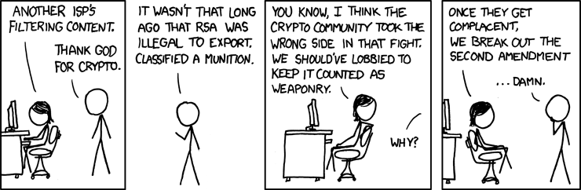
XKCD #504 “Legal Hacks”, © Randal Monroe, CC-BY-NC

